Waste Management Pilot Study Project
General Scope
The scope of the waste management pilot project includes the collection of wastes (glass, plastic, paper, mask and oil) separately according to recycling types at the site where they are generated as a result of education, training, research and service activities throughout our university, transporting them primarily for recycling in the facility and to ensure that wastes that cannot be converted into reusable products or converted into new products are disposed in accordance with the standards.
The Goal of the Project
This pilot study aims to raise environmental awareness on campus in order to prevent environmental pollution through processes such as reduction, classification, temporary storage, transportation, recovery, disposal, post-disposal control of wastes in the long term.
Project Duration
1 year
Project Method
In the first phase of the related project, a pilot study will be initiated for the collection of wastes such as glass, plastic, paper and masks. With this pilot study, we aim to raise awareness and create a waste management culture on our university campus. In order to create this awareness, student clubs have been contacted and they will work with this aim starting at the beginning of the spring semester.
Sample of the 4 bins which can be seen below will be placed at the 10 visible points, taking into account the size of our university and the number of buildings. Gurdag Waste Facility was contacted for the supply of these bins and the estimated cost was determined as 1600 Turkish Lira. Five other bins will be located next to the big canteens of our university as oil drums. Other smaller canteens will collect their own waste oil and pour it into designated oil bins once a week.
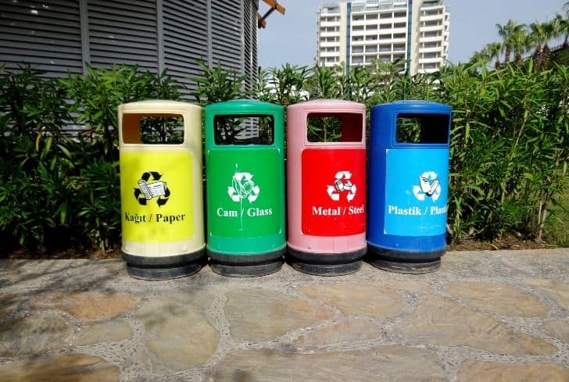Figure 1. Waste Bin
Smaller sized waste bins with 4 separate compartments (glass, plastic, paper, mask) to be placed at the exit of each building will be provided by an agreed sponsor. A person determined by the EMU Environmental Affairs office will be responsible for the collection and transportation of the wastes to large bins, under the control of the Administrative Supervisors of the buildings every 15 days.
Bins will be in different colors according to different types of waste and will have an identification label on them as seen in the Fig 1. All staff, students, external service providers and visitors will be informed about the university’s waste collection policy. The last collection area for the wastes collected from the bins will be the collection center to be established in the Water Works area of the Environmental Affairs Department within our university campus.
A pilot study will start at the beginning of the spring semester. All types and amounts of waste generated on campus such as batteries, electronic waste, chemical waste, etc. will be determined from the data collected at the end of academic year. A commission will be formed for planning the next period, and preparing a strategic plan, which will form the basis of the sustainable structure with the participation of all our stakeholders.
Regarding the collection of wastes from the campus, we will negotiate with the companies that can collect the waste based on the amount of waste on the campus, and then our resources will be shaped for our goal of being an exemplary university with environmental awareness in waste management in cooperation with the university-company or university-municipality.
Conclusion
As a result of the waste management pilot study, it is expected that an effective strategic plan will be prepared in line with the above-mentioned objectives, which will create a sustainable system in which these objectives can be achieved in the long term. This plan ensures increasing environmental performance, gaining advantage in national and international competition, increasing the reputation and quality of our university, increasing efficiency and using resources effectively, reducing or completely eliminating environmental effects that may occur in emergencies, controlling and reducing pollution starting from the source, complying national and international environmental laws and regulations and minimizing waste on campus.

Steps to be taken:
1. Supply of waste bins
2. Placement of bins at 10 visible points of the university
2.1 Dormitories area
2.2 Central classrooms area
2.3 Cafeterias
2.4 Entrances and Exits of campus
2.5 South campus
3. Joint awareness study with student clubs
4. Giving information about the collection of oil waste to canteens and cafeterias
5. Identification of the staff responsible for the transportation of the oils collected from the canteens and the wastes in the drums on the campus to the Water Works final collection area.
6. Determination of the total amount of waste at the end of the semester

Waste Management 6 Months Planning (February-August 2022)
• February-March 2022: Allocating waste bins and determining the locations to be placed
• March-April 2022: Placing the bins at the designated points and determining the responsible staff (definition of duties and responsibilities, starting awareness-raising activities-education-poster-inclusion of clubs, etc.)
• April-May 2022: Follow-up of the process
• May-June 2022: Determination of waste types and amounts at the end of the semester
• June-August 2022: Determining the institutions to be agreed for the collection of wastes according to the determined amount of waste and establishing a commission to achieve a sustainable structure.

